PRS portability for colorectal cancer across 1000 Genomes ancestries
BIOT 6900 · Computational Lab 6 (Module 6, Part 3) · Drashti Bharat Bhanushali · 29 October 2026

Setup and data
My disease from Modules 2-4 was colon adenocarcinoma. The PGS Catalog doesn’t have scores for colon adenocarcinoma specifically, only for colorectal cancer as a whole, so I used colorectal cancer here. In Module 2 I looked at somatic mutations in the tumour (KRAS, TP53, APC). A PRS is a different thing: it uses common inherited variants to estimate who is more likely to get the cancer in the first place.
Score: PGS000148 (CRC63, Jeon et al., Gastroenterology 2018). It has 63 SNPs, and the log-odds weights were estimated in European-ancestry samples only.
Data note. The data.zip on Canvas only has the 22 Alzheimer’s SNPs, so the genotypes for my score’s SNPs weren’t in it. I rebuilt all four input files myself with prepare_crc_data.py, using the same sources as the course files: the PGS Catalog harmonized scoring file and 1000 Genomes phase 3 (GRCh37). I kept the same 2,336 people, ancestry labels and ages as the class cohort. Because of this my checksums won’t match the ones in the Canvas README (those are for the Alzheimer’s files). The matching checksums are in data/README.md, which the prep script writes.
The phenotype is simulated, and so is the age effect. I followed the recipe in the Canvas README and didn’t change any of the settings (seed 6900, ±250 kb window, r² > 0.6 in EUR, noise SD 2.09, top 30% = cases). So the PRS and how it is distributed across ancestries come from real genotypes and real weights, but every AUC and calibration number depends on the simulated label. Those numbers show the effect, they don’t measure real colorectal cancer risk.

Proof of data (Section 2 output)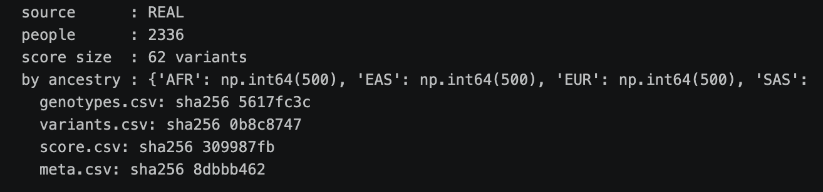
USE_DEMO = False for this run.

Results summary

3.1 Harmonization
Used 61, flipped 28, dropped 1, not found 1. Here is how the 63 published SNPs break down:
- 63 SNPs in the published score.
- 1 not found: rs202110856 has no record in 1000 Genomes phase 3 at its GRCh37 position, so it isn’t in the panel and can’t be scored. That leaves 62 in score.csv (the “score size” in the proof block).
- 1 dropped by keep/flip/drop: rs7229639 (SMAD7). The effect_allele in the published row is blank, so it’s not clear which allele the 0.023 weight belongs to. It matches neither REF nor ALT, so the rule drops it. I kept this locus in the simulated disease, so the score loses a small real signal, like it would in practice.
- 61 used, of which 28 needed flipping (effect allele = REF).
Three of the SNPs are strand-ambiguous (A/T or C/G: rs812481, rs35360328, rs16941835), and keep/flip/drop can’t catch a strand flip at those. I kept them because both the PGS Catalog file and the 1000 Genomes VCF are on the + strand. As a check that alleles lined up correctly, EUR cases score higher than EUR controls (AUC 0.685).

Main numbers (3.2-3.5)
 | EUR | AFR | EAS | SAS | AMR | Overall
n | 500 | 500 | 500 | 489 | 347 | 2,336
Mean PRS (SD units) | +0.16 | −0.09 | −0.17 | +0.30 | −0.28 | 0
% above pooled top-10% cutoff (PRS > 1.282) | 12.2 | 8.4 | 7.2 | 14.9 | 6.3 | 10.0
% cases (simulated) | 30.0 | 26.6 | 28.2 | 38.0 | 26.2 | 30.0
AUC (3.4) | 0.685 | 0.567 | 0.689 | 0.606 | 0.670 | 0.647
Mean tag-causal r² | 0.83 | 0.45 | 0.76 | 0.77 | 0.74 | -
O/E, EUR-fitted model (3.5) | 1.00 | 0.99 | 1.10 | 1.20 | 1.08 | -

3.6 Incremental value
With 5-fold CV on the pooled cohort, age alone gives AUC 0.579 and age + PRS gives 0.666, so the PRS adds 0.087. For comparison, the PGS Catalog entry for PGS000148 reports an AUROC of 0.59 in a European validation set, with age, family history, study and endoscopy history as covariates.
The mean tag-causal r² values come from data/README.md, which prepare_crc_data.py writes when it builds the simulated phenotype.

1. Why the European-derived score loses accuracy in other ancestries
In the simulation, each causal SNP has the same effect in every ancestry, and the same liability rule applies to everyone. So the biology is held constant, and any difference between groups has to come from LD and allele frequency.
LD: the score SNPs are tags
The 63 SNPs are GWAS hits. They were picked because they correlate with a causal variant in Europeans. A tag only carries signal to the extent it is in LD (r²) with the causal variant in the population you use it in.
 | EUR | AFR | EAS | SAS | AMR
Mean tag-causal r² | 0.83 | 0.45 | 0.76 | 0.77 | 0.74

African populations have the largest long-term effective population size, so recombination has broken haplotypes into shorter LD blocks. A tag that sits on the same haplotype as the causal variant in Europeans often doesn't in Africans. AFR has by far the lowest mean r² (0.45 vs 0.83 in EUR) and also the lowest AUC (0.567 vs 0.685).
Allele frequency decides whether losing LD actually costs anything
How much a loss of LD hurts also depends on how common the tag is in that group. A SNP that barely varies in a population adds almost nothing to the score there, so poor tagging costs almost nothing either. A tag that is common but in weak LD with its causal SNP is worse: its weight lands on a variable that is mostly noise. So the same drop in r² can be harmless in one population and harmful in another.

EAS does about as well as EUR here (0.689 vs 0.685). Part of the reason is the simulation itself: five tags, including the largest weight, rs11064437 (0.218), had no LD neighbour and became their own causal SNPs (listed in data/README.md), so they are perfectly tagged in every ancestry. In reality the causal variant is rarely the GWAS lead SNP itself, so I wouldn't read this as the score being portable to East Asians.
SAS I can't fully explain. Its mean r² (0.77) is about the same as EAS, but its AUC is lower (0.606). With about 490 people per group, an AUC has a standard error of roughly ±0.03, so some of this is probably noise. Also, mean r² weights every tag the same, while the AUC depends on which tags actually vary in that group. So one averaged r² number isn't enough to predict portability.
Allele frequency also shifts the whole distribution
The PRS is a sum of effect alleles, so a group that carries more of them scores higher whether or not its risk is actually higher. The net shifts here are small (EUR +0.16, SAS +0.30, AFR −0.09, EAS −0.17, AMR −0.28). PGS000148's weights come from a joint model, so some loci carry several SNPs with opposite-sign weights (e.g. the FADS1/2 SNPs on chr11). A group's mean PRS therefore partly depends on how frequency differences at those SNPs happen to cancel out.
Two more reasons: the SNPs were found in a European GWAS, so loci that matter mainly in other ancestries were never picked up. And the SNPs the score is missing (rs202110856, rs7229639) lower accuracy in every group.
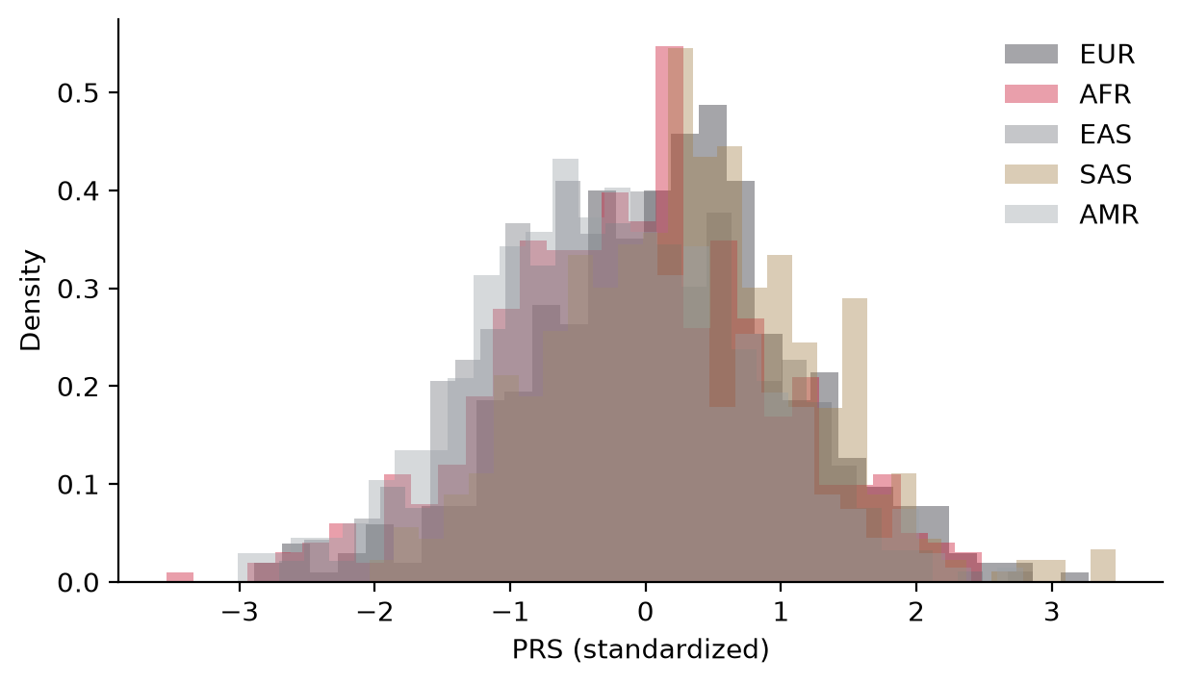
Figure 1. PRS distribution by ancestry (3.3)

2. One threshold, many groups
The pooled top-10% cutoff (PRS > 1.282, 3.3) flags 12.2% of EUR, 8.4% of AFR, 7.2% of EAS, 14.9% of SAS and 6.3% of AMR, a 2.4-fold spread between SAS and AMR.

I don't think the single cutoff is fair, but not only because the flag rates differ. Different flag rates could be fine if the groups really have different risk, and here they roughly do: SAS has the most simulated cases (38.0%) and is flagged most, while AMR, EAS and AFR (26-28% cases) are flagged least. The better question is whether a flag means the same thing in every group, and that depends on how well the score ranks people there. In EUR, EAS and AMR it ranks moderately well (AUC 0.67-0.69), so a flag carries real information. In AFR it barely ranks people (AUC 0.567) and the calibration curve is flat (3.5), so being above the cutoff tells an AFR patient much less than it tells a European patient.
If a clinic used it unchanged
The most likely real use of a CRC score is risk-adapted screening, meaning earlier or more frequent colonoscopy for people above the cutoff. That was also the goal of Jeon et al. If a clinic used this cutoff as is:
- AFR patients would be triaged close to at random. About 42 of the 500 (8.4%) would be flagged for earlier colonoscopy, but with an AUC of 0.567 those flags pick out cases only slightly better than chance, so most AFR cases would not get earlier screening. This is a bigger concern for CRC because in the US, Black Americans have some of the highest colorectal cancer incidence and mortality. An unadjusted EUR score could push the group with the highest burden to the back of the queue.
- EAS and AMR are flagged least (7.2% and 6.3%). The score ranks reasonably well in both (AUC 0.689 and 0.670), but each group is 26-28% cases and only 6-7% is flagged, so most of their cases are bound to fall below the cutoff and would be missed.
- The worst version would be the reverse: using a low score as a reason to delay screening. Then a missed flag turns into a missed cancer.
Group-specific cutoffs (the top 10% within each ancestry) would make flag rates equal, but they can't add accuracy, and in AFR they would still flag people the score can barely rank. Super-population labels are also crude. AMR and AFR include admixed populations (MXL, PUR, ASW, ACB), and a lot of patients don't fit one label. Standardizing the PRS against continuous genetic ancestry (principal components), like the PGS Catalog calculator and eMERGE do, fixes the shift in the mean but not the accuracy problem in AFR. Equal flag rates aren't the same as equal accuracy.
Ethically, the main issue is that the people who would be harmed most here are in the group with the highest real-world burden, and they also had the least say in the data the score was built on. Using it unchanged would add to an existing disparity instead of reducing it.

3. Discrimination vs calibration
Discrimination (3.4) asks whether the score ranks a random case above a random control within a group. It doesn’t care if the whole distribution is shifted up or down. The score ranks moderately well in EUR, EAS and AMR (0.67-0.69), worse in SAS (0.606), and only a bit better than chance in AFR (0.567). So AUC picks up the LD problem, but it ignores the shift in the whole distribution.
Calibration (3.5) asks whether a predicted 30% risk actually means 30%. I fit the logistic model in EUR only (intercept −1.054, slope 0.720 per SD) and applied it to everyone.
- EUR looks perfect (0.300 predicted vs 0.300 observed), but that’s expected, since the model was fit on those same people. EUR is the training set here, not a validation.
- AFR is right on average (0.268 predicted vs 0.266 observed), but the curve is flat. Predicted risk goes from 0.11 to 0.47 across quintiles, while observed risk only moves between 0.16 and 0.34.
- SAS is under-predicted overall (0.318 vs 0.380, O/E 1.20). It’s worst in the bottom two quintiles: predicted 0.15 and 0.23, observed 0.32 and 0.32. So SAS people with low scores have about twice the risk the model gives them.
- EAS and AMR are close and slightly under-predicted (O/E 1.10 and 1.08). Their curves follow the diagonal.
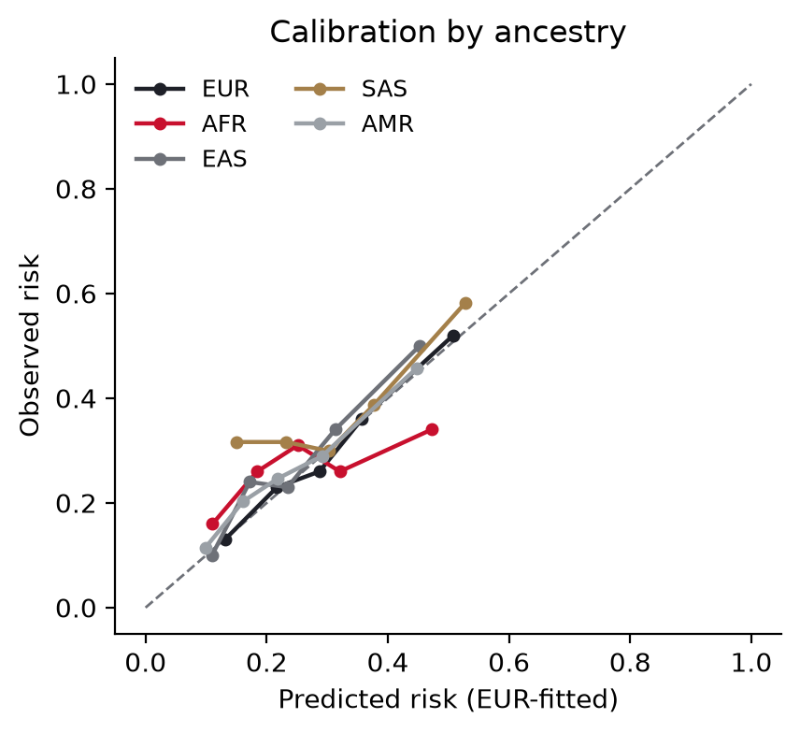
Figure 2. Calibration by ancestry, EUR-fitted model (3.5)
Where they disagreed
- AFR passes average calibration but fails everything else. Its O/E of 0.99 is the best of any group apart from the training set, so if you only looked at mean calibration, AFR would look like the best group. But the AUC (0.567) and the flat curve show the model can barely rank people there. The average only works out because over- and under-predictions cancel. At the top end, the highest AFR quintile is predicted at 0.47 risk but observed at 0.34, while the highest EUR quintile is predicted at 0.51 and observed at 0.52. The model is honest at the top for Europeans and overstates risk for African-ancestry people.
- EAS ranks as well as EUR but isn’t calibrated. The AUC is the same (0.689 vs 0.685), but risk is under-predicted by 10% overall. Good ranking doesn’t mean correct absolute risk. EAS mostly needs a new intercept.
- SAS has the worst calibration but only a moderate drop in AUC. Its baseline risk is different from EUR’s, and a PRS-only model can’t learn that. SAS needs a new intercept and slope, while AFR needs a better score.
One caveat: each calibration point is a quintile of about 70-100 people, so each observed rate has a standard error of roughly ±5 percentage points. The flat AFR curve, the AFR top-end gap and the SAS low-end gap are well outside that. The small wiggles in the EUR and AMR curves aren’t.

4. Clinical utility and limits
What the score adds on top of age (3.6)
Pooled, the PRS adds 0.087 to the cross-validated AUC (0.579 → 0.666). That gain is pooled across ancestries, so most of it likely comes from the groups where the score ranks well (EUR, EAS, AMR). Given an AUC of 0.567 in AFR, it probably adds little there.

Since both the age effect (0.35 per 8 years) and the phenotype are simulated, none of this measures real incremental value. Real CRC risk rises much more steeply with age than this.
Where it could help
- Risk-adapted screening in European-ancestry adults, which is what the score was built for. For example, starting colonoscopy or FIT earlier for people at the top of the distribution. CRC suits this because screening is effective and cheap, so even a modest AUC can be useful when it only changes when someone gets screened, not whether they get treated.
- Choosing a screening method, e.g. colonoscopy for high-PRS people and FIT for average risk, in a population where the score has been validated.
- Research, e.g. enriching prevention trials (aspirin, diet) with higher-risk European-ancestry participants.
Where it should not be used
- To delay or skip screening because of a low score, in any ancestry. Most CRC cases happen in people with average scores, and guideline screening from 45 already covers everyone.
- In African-ancestry patients, where it barely discriminates, and in admixed patients, where it hasn’t been validated.
- As a replacement for hereditary cancer testing. Lynch syndrome (MLH1, MSH2, MSH6, PMS2) and FAP (APC) are caused by rare high-penetrance variants that a 63-SNP common-variant score can’t pick up. Family history or early-onset cancer needs a germline panel, not a PRS.
- To say anything about a tumour. The KRAS, TP53 and APC findings from Module 2 are somatic, and this score is germline.
- For insurance or employment decisions, or direct-to-consumer reporting without genetic counselling.
What I would need before deploying it
- A real phenotype. Everything in 3.4-3.6 depends on a simulated label and simulated age. To validate for real I would need registry- or pathology-confirmed incident colorectal cancer in genotyped people, with age at diagnosis, sex, family history, screening/colonoscopy history (removing polyps prevents cases, which biases who becomes a case), subsite (colon vs rectum, which matters since my disease is colon adenocarcinoma), and enough cases in each ancestry. Datasets I would look at: UK Biobank and FinnGen (registry-linked, mostly European), the GECCO/CORECT/CCFR consortia, the Multiethnic Cohort (African American, Japanese American, Latino and Native Hawaiian participants), the Southern Community Cohort Study (mostly African American), All of Us and the Million Veteran Program (EHR outcomes across ancestries), and Biobank Japan, China Kadoorie Biobank and the Asia Colorectal Cancer Consortium. African-ancestry CRC GWAS data is still small, and that’s the biggest gap.
- Multi-ancestry weights. There are already candidates in the PGS Catalog, e.g. PGS003852 (Thomas et al. 2023, trained on European and East Asian data). None have enough African-ancestry training data, so new GWAS would be needed. Methods like PRS-CSx can combine ancestries.
- Calibration within each ancestry (intercept and slope) plus continuous-ancestry standardization, checked using the calibration slope and the case rate in flagged people, not just overall O/E.
- Absolute 10-year risk at a given age, accounting for competing causes of death, and combined with family history and lifestyle like Jeon et al. did. “Top 10%” isn’t something a patient can act on.
- Prospective evidence that PRS-guided screening finds more early cancers or advanced adenomas per colonoscopy than age-based screening, without widening disparities.
- Governance: consent, counselling, data protection, and clear rules against using a low score to deny or delay screening.

5. Artifact versus biology
The score does worst in AFR (AUC 0.567), but I don't think that shows the colorectal cancer loci matter less in African-ancestry people. It's mostly a property of how this dataset was simulated.
The main reason is how the causal SNPs were picked. For every tag, the simulation chose its hidden causal SNP from SNPs in strong LD with the tag in Europeans (r² > 0.6 in EUR). So by design, the score tags its causal SNPs best in EUR. In AFR, where LD blocks are shorter, those same tags only reach a mean r² of 0.45. The LD differences themselves are real, since they come from the actual 1000 Genomes genotypes. But how big the AFR drop looks depends on that design choice. A different way of picking causal SNPs would give a different drop.
The simulation also gives each causal SNP the same effect in every ancestry. So within this dataset, the loci matter exactly as much in AFR as they do in EUR. The score just can't see them as well, because it's reading the wrong SNPs. A low AUC here measures how well the tags track the causal variants, not how important the biology is.
A few other results come from the setup, not biology:
- EAS doing as well as EUR is partly because five tags, including the largest weight, became their own causal SNPs. That makes them perfect tags in every ancestry, which wouldn't happen in reality.
- The higher case rate in SAS (38.0%) comes from the simulated causal-allele frequencies. It isn't a claim about real colorectal cancer rates in South Asians, which are lower than in Europeans.
- rs7229639 was dropped from the score but kept in the simulated disease. So some signal is lost in every group for a purely technical reason: a blank effect allele.
In real data, a European score would probably still lose accuracy in African-ancestry people. That would be for the same kinds of reasons: different LD, different allele frequencies, and risk variants that a European GWAS never found. But the exact size of the drop in this report can't be trusted as a real-world estimate. Getting that would need real colorectal cancer cases in African-ancestry cohorts, which is the data gap I describe in Q4.

